**Worksheet-3.1**

**Student Name**: Sahil Kaundal **UID:** 21BCS8197

**Branch**: CSE(LEET) **Section/Group:** 807/B

**Semester**: 4th **Date of Performance**: 21/04/2022

**Subject Name**: CN Lab **Subject Code:** 20CSP-257

1. **Aim/Overview of the practical:**

Create a network that implement the FTP server.

1. **Task to be done/ Which logistics used:**

Create a network that implement the FTP server.

**Understand Routing Mechanism** - Sharing of resources with two connected nodes. Understanding FTP Configure a network using Link State Routing Protocol using Packet Tracer.

1. **Apparatus/Simulator used** **(For applied/experimental sciences/materials-based labs):**

Cisco Packet Tracer

1. **Steps:**

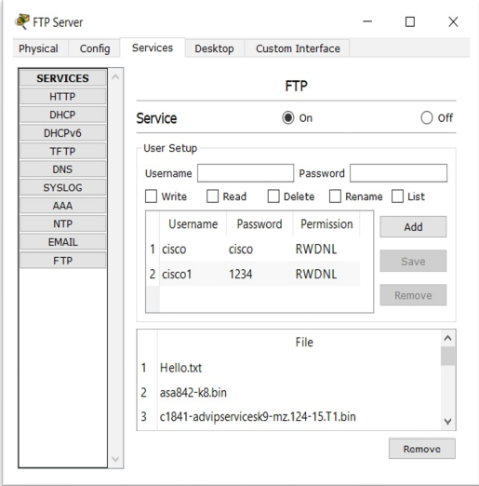

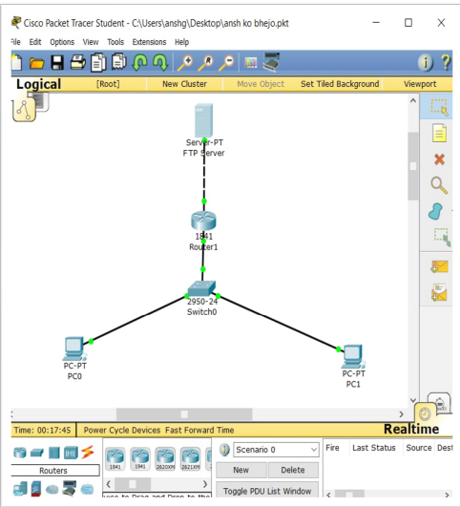

**Result: -**

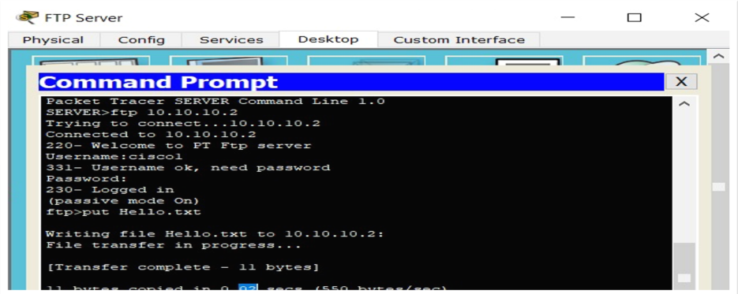

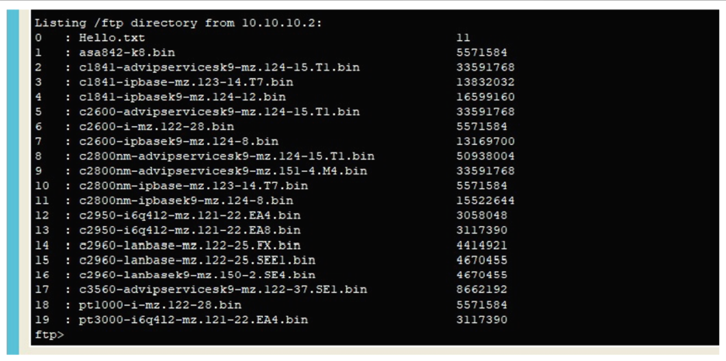

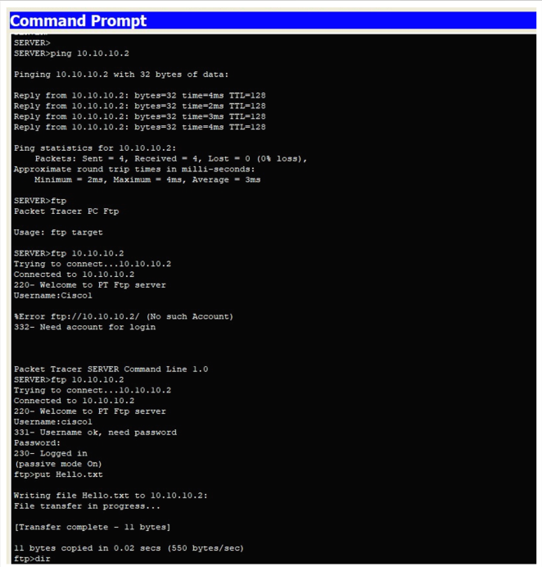

I have successfully completed this experiment.

**Learning outcomes (What I have learnt):**

1. Understand Routing Mechanism - Sharing of resources with two connected nodes. Understanding FTP Configure a network using Link State Routing Protocol using Packet Tracer.
2. Created a network that implement the FTP server.

**Evaluation Grid (To be created as per the SOP and Assessment guidelines by the faculty):**

|  |  |  |  |
| --- | --- | --- | --- |
| Sr. No. | Parameters | Marks Obtained | Maximum Marks |
| 1. |  |  |  |
| 2. |  |  |  |
| 3. |  |  |  |
|  |  |  |  |